ESP 3 Inventory Control Sheet (Suppliers)
Legend Bold primary key
Italic foreign key
BoldItalic primary/foreign key
  - Inventory Item
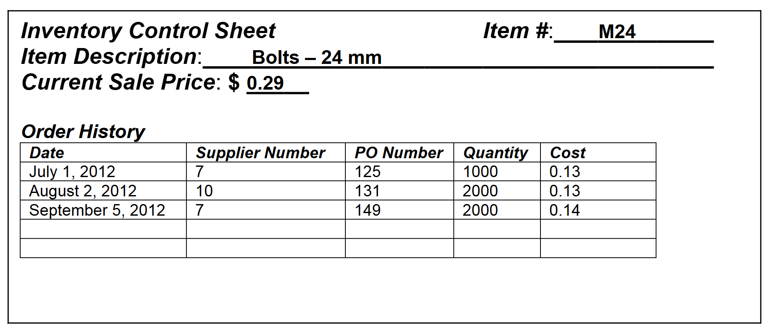
0NF
Reading the narrative of the form, and taking into account the additional data requested for tracking, two new fields are added to this form view: InStockQuantity, ReOrderLevel
Item(ItemNumber, Description, CurrentSalePrice,(PurchaseOrderDate, SupplierNumber, PONumber, Quantity, Cost), InStockQuantity, ReOrderLevel)
1NF
Item (ItemNumber, Description, CurrentSalePrice, InStockQuantity, ReOrderLevel)
PurchasedOrderItem (ItemNumber, PONumber, PurchaseOrderDate, SupplierNumber, Quantity, Cost)
2NF
Item ( ItemNumber, Description, CurrentSalePrice, InStockQuantity, ReOrderLevel)
PurchasedOrderItem (ItemNumber, PONumber, Quantity, Cost)
PurchaseOrder (PONumber, PurchaseOrderDate, SupplierNumber)
3NF
Item ( ItemNumber, Description, CurrentSalePrice, InStockQuantity, ReOrderLevel)
PurchasedOrderItem (ItemNumber, PONumber, Quantity, Cost)
PurchaseOrder (PONumber, PurchaseOrderDate, SupplierNumber)
  - Purchase Order View
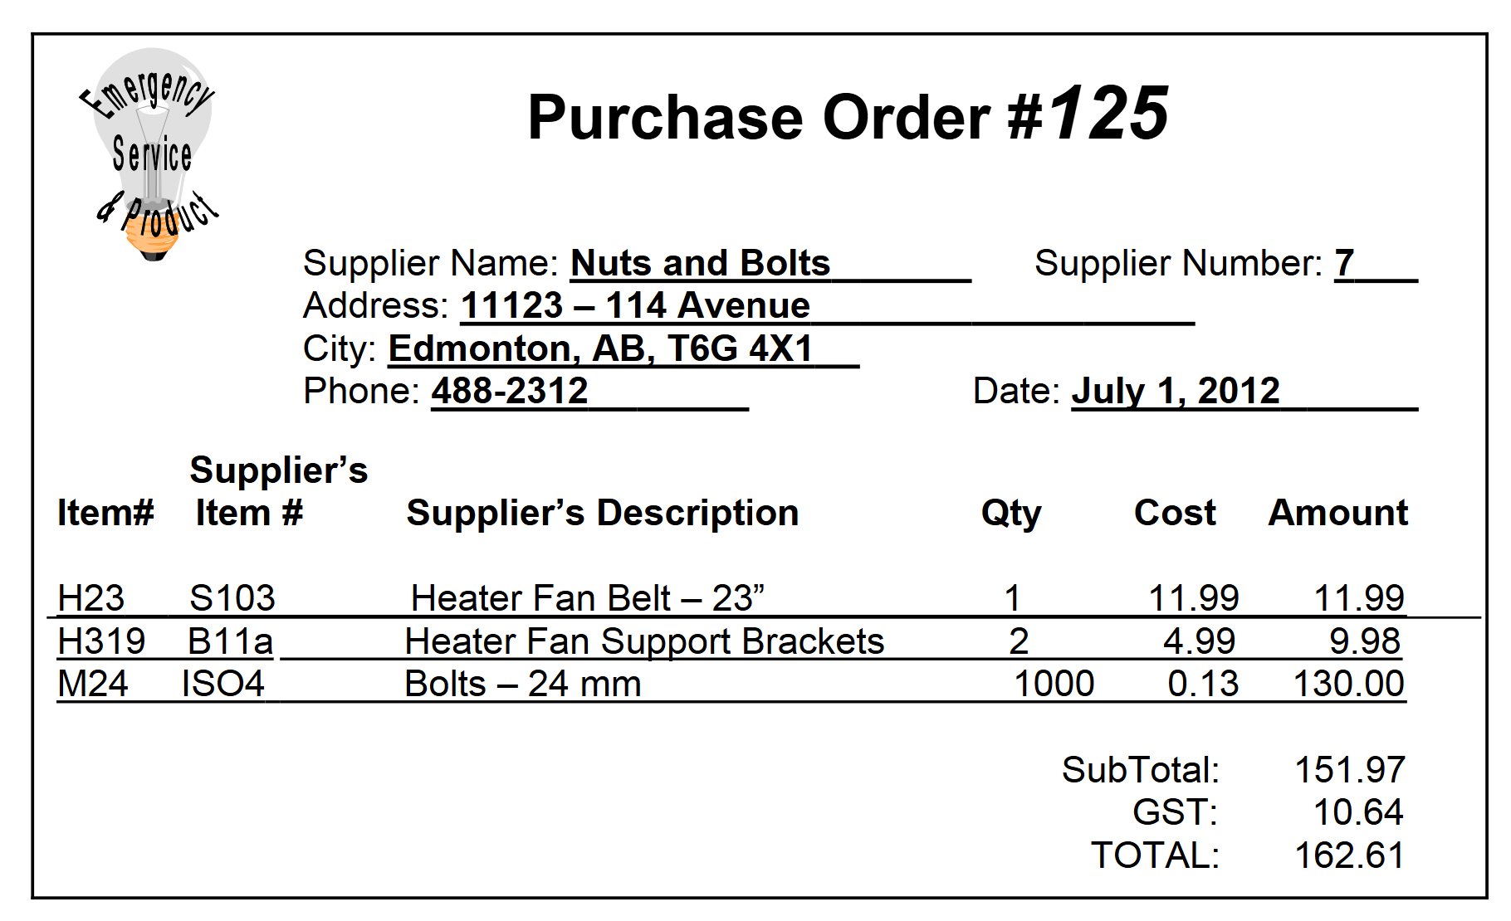
0NF
PurchaseOrder (PurchaseOrderNumber, SupplierName, SupplierNumber, Address, City, SupplierPhone, PurchaseOrderDate, (ItemNumber, SupplierItemNumber, SupplierDescription, PurchaseQuantity, PurchaseCost, PurchaseOrderAmount), Subtotal, GST, Total)
1NF
PurchaseOrder (PurchaseOrderNumber, SupplierName, SupplierNumber, Address, City, Province, PostalCode, SupplierPhone, PurchaseOrderDate, Subtotal, GST, Total)
PurchaseOrderItem (PurchaseOrderNumber, ItemNumber, SupplierItemNumber, SupplierDescription, PurchaseQuantity, PurchaseCost, PurchaseOrderAmount)
2NF
PurchaseOrder (PurchaseOrderNumber, SupplierName, SupplierNumber, Address, City, Province, PostalCode, SupplierPhone, PurchaseOrderDate, Subtotal, GST, Total)
PurchaseOrderItem (PurchaseOrderNumber, ItemNumber, SupplierItemNumber, SupplierDescription, PurchaseQuantity, PurchaseCost, PurchaseOrderAmount)
Often you may have a situation where current and historical data needs to be maintained.
This may lead to the creation of a new attribute and clarification between the existing attribute and the new attribute.
3NF
PurchaseOrder (PurchaseOrderNumber, SupplierNumber, PurchaseOrderDate, Subtotal, GST, Total)
PurchaseOrderItem (PurchaseOrderNumber, ItemNumber, SupplierItemNumber, PurchaseQuantity, PurchaseCost, PurchaseOrderAmount)
Supplier (SupplierNumber, SupplierName, Address, City, Province, PostalCode, SupplierPhone)
SupplierCatalog (SupplierItemNumber, SupplierDescription, CurrentPurchaseCost)*
- If we are tracking the supplier catalog, we will need to update the catalog data as the supplier changes their information. Do we want to add this addition work to our database
- If not, then the data should not be tracked
- Even though you might want both current and historical data, the additional work may not be desired.
- Due to this reasoning, CurrentPurchaseCost, could be reasonably removed from your design.
- SupplierCatalog (SupplierItemNumber, SupplierDescription, CurrentPurchaseCost)*

Merging

Item ( ItemNumber, Description, CurrentSalePrice, InStockQuantity, ReOrderLevel)
PurchaseOrderItem (PurchaseOrderNumber, ItemNumber, SupplierItemNumber, PurchaseQuantity, PurchaseCost, PurchaseOrderAmount)
PurchaseOrder (PurchaseOrderNumber, SupplierNumber, PurchaseOrderDate, Subtotal, GST, Total)
Supplier (SupplierNumber, SupplierName, Address, City, Province, PostalCode, SupplierPhone)
SupplierCatalog (SupplierItemNumber, SupplierDescription)*
Customer (CustomerNumber, FirstName, LastName, Address, City, Province, PostalCode, HomePhone)
Order (OrderNumber, CustomerNumber, OrderDate, Subtotal, GST, Total, BalanceOwning)
OrderItems (OrderNumber, ItemNumber, Quantity, OrderPrice, Amount)
PaymentLog (PaymentLogID, OrderNumber, CustomerNumber)
PaymentLogDetail (PaymentLogID , PaymentNumber, PaymentDate, PaymentAmount, PaymentTypeID, DepositBatchNumber)
PaymentType (PaymentTypeID, PaymentTypeDescription)

